Table 1. Transfer time data for all studies
 | Number of prisoner transfers | Gender | Destination of transfer | MHA Sections used | Time period | Mean overall transfer time from referral to admission (days) | Mean transfer times / transferred to breakdown (days) | Reasons for delay / failure to transfer
Carroll et al, 2021  (Australia) | Missing data | Missing data | Missing data | Missing data | Missing data | Missing data | Missing data | Adult male remand or sentenced prisoners are almost never transferred to hospital units for involuntary treatment of mental  illness. Only female and juvenile prisoners are infrequently transferred
Woods et al, 2020 | n = 173 | Male 100% | High (n=12)  Medium (n=98)  Low (n=20)  PICU (n=34)  Other (n=9) | Missing data | Sept 2010-Sept 2016 (6 years) | n = 171 (completed)  57.8 (SD 70.5) | High 159.6 (SD 115.7)  Medium 58.5 (SD 67.1)  Low 54.8 (SD 52.9)  PICU 16.1 (SD 11.3)  Other 68.7 (SD 53.2) | A shortage of forensic beds and disagreements as to the level of security required contributing to significant delays in transfers
Okudo, 2020 (Scotland) | n = 124 | Male 105 (84.7%)  Female 19 (15.3%) | High (n=22)  Medium (n=13)  Low (n=7)  IPCU (n=70) | 85 x 52 (remand)  39 x 136 (sentenced) | 1st January 2016-31st December 2016 | n = 112 (completed)  21.5 (SD 29.7) | n=60 (80%) within 1 month  n=12 (16%) between 1 and  3 months  n=2 (2.7%) between 3 and 6 months  n=1 (1.3%) longer than 6 months | The required assessment by clinicians from high-secure likely prolonged transfer duration and potentially delayed access to inpatient care. Also, disagreements over  the appropriate level of security and difficulties accessing the prisoner have  previously been reported to contribute to transfer delays
Skipworth et al, 2019  (New Zealand) | Missing data | Male 358 (93%)  Female 28 (7%) | Missing data | Missing data | 1988-2000 | Missing data | Missing data | Prisoners with SMI with higher rehabilitation  needs could be transferred to forensic hospital beds, though these transfers are under such pressure that this is currently unlikely to be feasible.
Bones & Roberts, 2019  (Ghana) | n = 2 | Male 2 (100%) | Pantang Psychiatric Hospital | Missing data | November 2013 | Missing data | One patient had been detained in Prison for four years before his transfer | The fundamental factor revealed is the lack of an efficient interface between mental health and relevant criminal justice partners
Neeilan & O’Brien, 2017* | n =18 | Male 100% | *Returned to prison* | 9 x 47/49  9 x 48/49 | Jan 2008-Dec 2014 (7 years) | n = 5 (completed)  14.6 (SD 25.03)  * transfers back to prison | Prison 14.6 days (SD 25.03)  Community 1.86 days (SD 3.34) | The offender pathway requires further exploration to establish where the “blocks” are in delay of remittance of this group to prison.
Sharpe et al, 2016 | n = 64 | Male 100% | Missing data | 44 x 47/49  20 x 48/49 | Nov 2011-May 2015 (3 ½ years) | n = 64  75.81  (median 46) | n=9 (14%) within 14 days  n=8 (13%) within 1 month  n=30 (47%) between 1 and 3 months  n=11 (17%) between 3-6 months  n=6 (9%) longer than 6 months | Whilst transfers were made to units nationwide, the current study is limited by the fact that  the majority were to units in the East Midlands. The greatest proportion of the transfer delay can be attributed to responsibilities that lie with  the hospitals, including organising a gatekeeping assessment, deciding upon acceptance or rejection of the referral and identifying an available bed space. To have the greatest impact on reducing transfer durations these components require attention.
Hopkin et al, 2016 | n=71 | Male 100% | Medium (n=34)  PICU (n=15)  Acute/General (n=23)  Specialist (n=4) | 26 x 48/49  6 x 47/49  16 x 37 or 38  3 x 35 or 26  19 x 2  1 x voluntary admission | Jan 2011-Dec 2011 (1 year) | n = 62 (completed)  114  (Range 0-221) | 34% Under 3 months  27% 3-6 months  27% over 6 months  12% of transfers not completed | Disagreements between clinicians prevented transfer in four cases, and a further five prisoners were released before transfer could be completed
Bartlett et al, 2012 | n = 86 | Female 100% | WEMSS (n=5)  Medium (n= 33)  Low (n=6)  PICU (n=38)  Acute (n=4) | 19 x 47/49  38 x 48/49  29 x 35, 37, 38 | Jan 2008 - Oct 2010 (2 years 9 months) | n = 86  51  (Range 2–217) | n=11 (13%) of all transfers within 14 days  n=57 47/49 & 48/49 transfers mean 55 days  n=29 35, 37 & 38 transfers mean 43 days | Two hospital admissions were achieved using civil section 2 after release from court or after release from prison and these were the only transfers not completed from the sample
* Neeilan & O’Brien, 2017 is transfers back to prison from hospital
WEMSS = Women's Enhanced Medium Secure Service

Further pictures
Proposed solitary confinement space in China
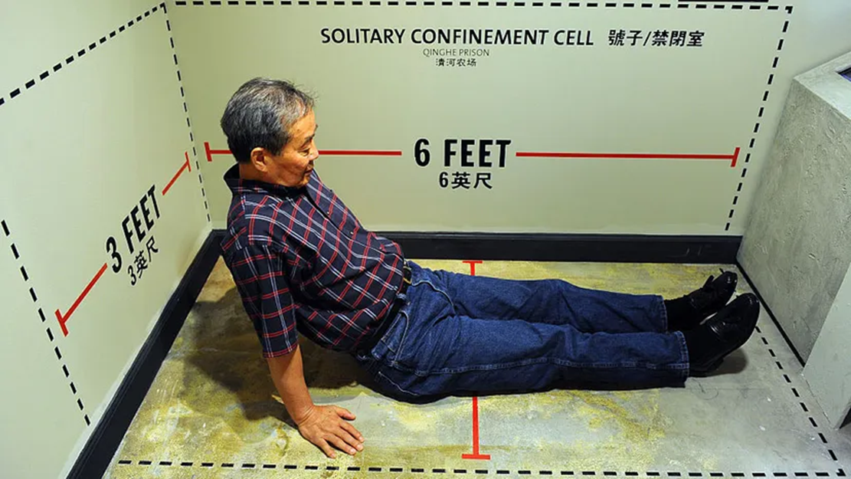

Typical UK prison segregation unit

References

- United Nations International Covenant on Civil and Political Rights, December 16, 1966, https://www.ohchr.org/en/instruments-mechanisms/instruments/international-covenant-civil-and-political-rights
- United Nations Convention against Torture and Other Cruel, Inhuman or Degrading Treatment or Punishment, December 10, 1984, https://www.ohchr.org/en/instruments-mechanisms/instruments/convention-against-torture-and-other-cruel-inhuman-or-degrading
- United Nations Convention on the Rights of Persons with Disabilities, December 13, 2006, https://www.ohchr.org/en/instruments-mechanisms/instruments/convention-rights-persons-disabilities
- United Nations Office on Drugs and Crime. (2015). The United Nations Standard Minimum Rules for the Treatment of Prisoners (the Nelson Mandela Rules). Retrieved from https://www.unodc.org/documents/justice-and-prison-reform/Nelson_Mandela_Rules-E-ebook.pdf
- Woods, L., Craster, L., & Forrester, A. (2020). Mental Health Act transfers from prison to psychiatric hospital over a six-year period in a region of England. Journal of Criminal Psychology.
- Sharpe, R., Völlm, B., Akhtar, A., Puri, R., & Bickle, A. (2016). Transfers from prison to hospital under Sections 47 and 48 of the Mental Health Act between 2011 and 2014. The Journal of Forensic Psychiatry & Psychology, 27(4), 459-475.
- Okudo, U. (2020). Transfers of remand and sentenced prisoners to hospital under the mental health (Care and Treatment) (Scotland) Act 2003. The Journal of Forensic Psychiatry & Psychology, 31(6), 1002-1019
- Bartlett, A., Somers, N., Reeves, C., & White, S. (2012). Women prisoners: an analysis of the process of hospital transfers. Journal of Forensic Psychiatry & Psychology, 23(4), 538-553.
- Carroll, A., Ellis, A., Aboud, A., Scott, R., & Pillai, K. (2021). No involuntary treatment of mental illness in Australian and New Zealand prisons. The Journal of Forensic Psychiatry & Psychology, 32(1), 1-28.
- Skipworth, J., Bevin, W., McKenna, B., Simpson, A. I., Brinded, P., & Pearson, J. (2019). Comparative outcomes for a national cohort of persons convicted of murder, with and without serious mental illness, and those found not guilty by reason of insanity on a murder charge: A 25‐year follow‐up study. Criminal behaviour and mental health, 29(5-6), 276-285.
- Bone, T. A., & Roberts, M. (2019). An investigation into the routes to inpatient care at the Pantang Hospital in Ghana via the criminal justice system. Ghana medical journal, 53(2), 100-108.
- Bradley (2009) The Bradley Report: Lord Bradley’s Review of People with Mental Health Problems or Learning Disabilities in the Criminal Justice System. The Stationery Office, London.
- Hopkin, G., Samele, C., Singh, K., & Forrester, A. (2016). Transferring London’s acutely mentally ill prisoners to hospital. Criminal Behaviour and Mental Health, 26, 76.

