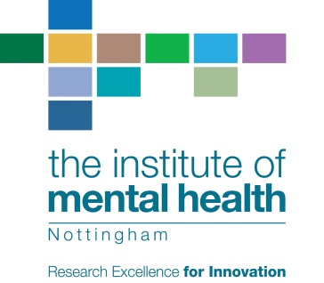

The Institute of Mental Health
2022 Publication Awards Entry Form

Name of Nominee:
Contact details for Nominee (including postal and email addresses):

Name of Nominator (if different to Nominee):
Contact details of Nominator (if different to Nominee):

Title and publication details of the relevant publication:

Please show the categories for which paper is nominated (delete/highlight/circle as appropriate):

- Best overall publication
- Best publication when the author has published no more than six previous publications
- Best publication flowing from work during doctoral studies or as part of a doctoral dissertation
- Best publication by an employee of Nottinghamshire Healthcare NHS Trust who does not have a substantive contract with a university
- Best publication co-authored with a person with lived experience of mental distress or a current or former user of mental health services
- Best publication (including blog posts, newspaper articles, or similar) by a person with an affiliation to the Institute of Mental Health who has lived experience of mental distress or is a current or former user of mental health services

Where there are multiple authors cited please provide a short statement explicating the nominee’s contribution to the composition of this publication:

For further details regarding the rules, please visit www.institutemh.org.uk or
contact Darren Wright, as below.
Please submit this entry form along with the publication (in PDF format) to Darren Wright at darren.wright@nottshc.nhs.uk by 28 February 2023.

