[Insert local Trust Logo]

The SATURN Study



Information for young people aged 11 – 15 years

Version 1.0 -06 OCT-2022
IRAS Project ID: 1005480

The SATURN study is looking to see
which medicine can help children and young people
with ADHD and tics best.

We need your help to do this!

We will ask an adult to take part in SATURN with you. This might be your Mum or Dad, or another adult who looks after you (e.g. a grandparent). In the rest of this leaflet, we will call them your ‘parent/carer’.

If you and your parent/carer agree to take part, we will put you into one of two groups:

Group 1: will take Medicine A (modified-release methylphenidate)
This will be a tablet or capsule taken once daily.

Group 2: will take Medicine B (guanfacine extended-release)
This will be a tablet taken once daily.

We will ask you and your parent/carer to fill in some questionnaires
during the study. The researcher will explain this to you when you talk to them.

This leaflet will tell you what to expect if you choose to take part in
this research study. If you have any other questions, we can answer
these when we speak to your parent/carer and you about the study.



B
A



1. Why is this study important?

Lots of children and young people with ADHD find it hard to pay attention and sit still. ADHD might also make it harder for them to control their behaviour and they might find it more difficult than other people to understand and express their feelings and emotions.
Some children and young people with ADHD also have ‘tics’. Tics are movements
or sounds that a person cannot control and that are repeated over and over.

Medicines to help with ADHD work very well. One type of medicine
that can be prescribed by doctors works by helping different parts of
your brain talk to each other, so you can focus on an activity like drawing or
homework for longer.

However, many doctors are worried that this type of medicine could make tics worse. This means doctors often prefer to give another type of medicine to people that have both ADHD and tics.

At the moment, doctors aren’t sure which medicine works best. In our study, we are looking to find out if one type of medicine works better than the other for children and young people with ADHD and tics.





2. Why have I been invited to help?
You have been invited to help because your doctor has diagnosed you with ADHD and you
also have tics. 314 children and young people will be helping us with this study.

3. Do I have to help?
You can decide whether or not to help with this study.
If you decide to help now but change your mind later, that is fine too. You can stop taking
part at any time without your current or future care or treatment being affected. If you do decide to no longer take part, it is very important that you don’t stop taking the medicine suddenly. You or your parent/carer must speak to your doctor first before you stop taking the medicine.

4. What will I have to do if I help?
We will ask your parent/carer to fill in a questionnaire on their computer – this will ask
questions about the things that are difficult for you and help us decide whether you can take
part in the SATURN study.
A member of the SATURN team will call your parent/carer to talk about the study and answer
any questions you might have. They will then ask your parent/carer a few more questions to
confirm you can be invited to a face-to-face appointment at the clinic.

In the clinic, you and your parent/carer will have the opportunity to ask any further
questions you may have.

Then you and your parent/ carer each sign a form that confirms you are both happy to take part in the study. If you turn 16 during the study you will be asked to sign a new form for 16 year olds to confirm you are happy to continue taking part.

Then we will:
- Ask you and your parent/carer some questions and help you complete some questionnaires.

- Measure your blood pressure, height and weight and take your pulse.

If it is possible that you could be pregnant, you will be given a pregnancy test. The research doctor will talk to you about this during the visit. Anyone who is pregnant or plans on being pregnant will not be able to help with the study.
- A special computer programme will choose which of the groups you will be in:

Group 1: You will take medicine A
Group 2: You will take medicine B

To decide which group you will be in, the computer uses a process called
randomisation. It works like flipping a coin.

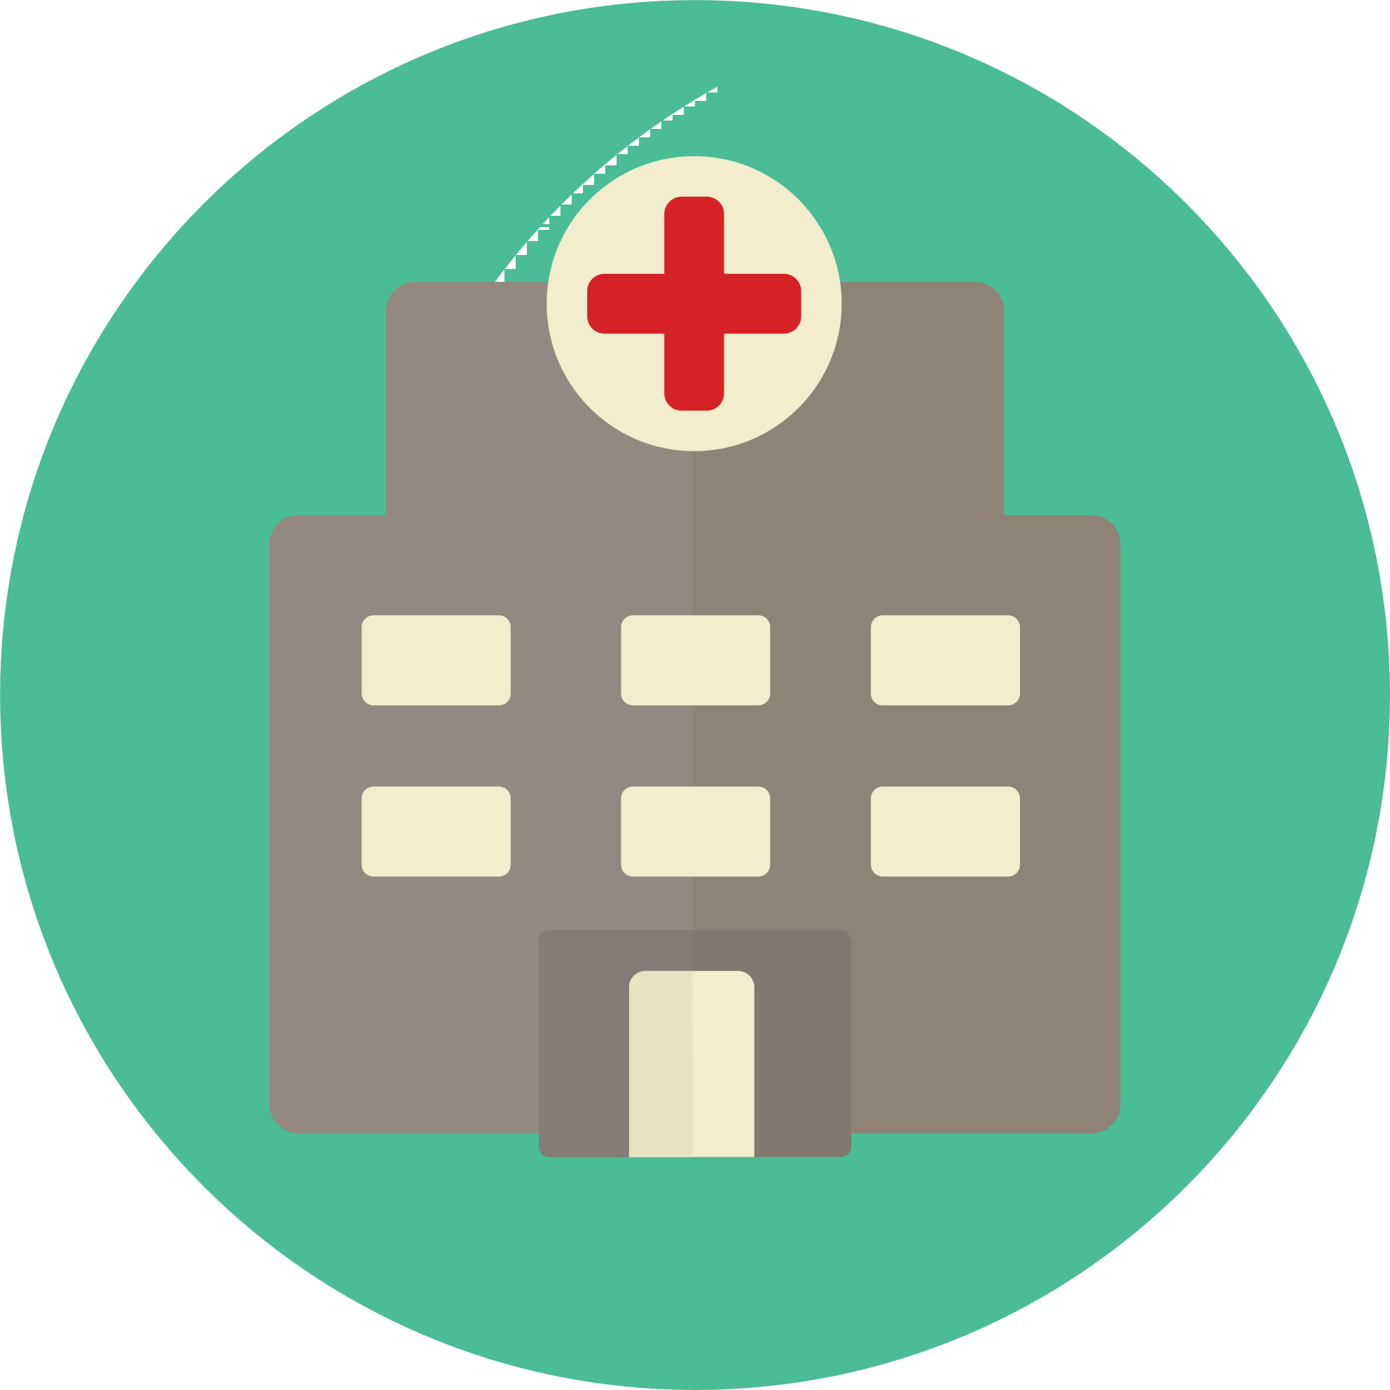








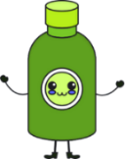
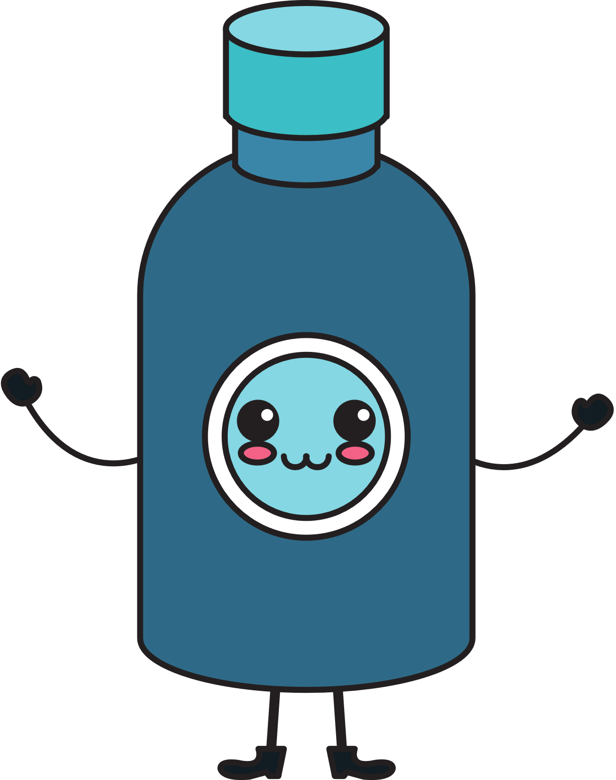

There will be follow up visits and questionnaires for you (if you would like to do so) and your parent/carer to complete (alongside taking your medication) which the SATURN research team will tell you about at your clinic visit. Visits may be done online, over the phone or in person. Your parent/carer will get reminders to help your family remember what needs to be completed and when. Any care and treatment (for example talking therapy) you normally receive will continue throughout the time you take part in the study - unless your usual care doctor (the doctor you see normally, not the study doctor) advises otherwise.

If you complete the follow up visits and questionnaires, your family (you and the parent/carer taking part with you) will be offered a total of £30 in e-vouchers at different times during the study as a thank you for the extra time you are spending taking part in SATURN.
Your family will also be entered into a number of prize draws (e.g. for an electronic tablet) as a thank you for taking part in SATURN.




5. What will happen if I don’t want to carry on with the study?
If you change your mind at any time and don’t want to carry on in the study, that is okay. Taking part in this study is your decision.
If you are unsure at any stage, then please speak to your parent/carer about how you are feeling. You can also tell someone in the SATURN research team.

6. Is there anything else I should know?
Any information we collect about you will remain confidential; this means we will not share it with people who are not working on the study.
The information will also be anonymous, which means we do not use your name.
There is a small chance that you may get side effects from the medicine that you are taking. Some of the most common side effects are:
- Medicine A (modified-release Methylphenidate): feeling nervous, not being able to sleep or having a headache.
- Medicine B (Guanfacine extended-release): feeling sleepy and/or tired, having a headache, having tummy pain.
If you have any questions or feel upset about taking part, you should speak to your parent/carer.

7. How to contact us:
<insert local team contact details>

<insert research team contact details>


This project is funded by the National Institute for Health and Care Research (NIHR) Health Technology Assessment (HTA) Programme. Project Ref: NIHR128472. The views expressed are those of the author(s) and not necessarily those of the NIHR or the Department of Health and Social Care.

